**CHAPTER 1**

**INTRODUCTION**

* 1. **Background of the Study**

The Philippine Archipelago has approximately 7000 islands located in the Western Pacific. The Philippines, as a country surrounded by water, is one of the highest contributors of plastic waste in the marine environment. Data shows that the country contributes 0.28-0.75 million metric tons of plastic per year (Jambeck, Geyer, Wilcox, Siegler, Perryman, Andrady & Law, 2015).

Plastics scattered throughout the ocean which subsequently resulted in different patches. Chemicals from plastics are spread into the atmosphere as well as the water that are damaging to humans. Chemicals from plastics like lead, cadmium, and mercury, in direct contact with humans, are dangerous which are associated with cancer, birth defects and immune system problems (Andrews, 2012).

With unmanned technology, in recent studies, show successful machines with no humans on board (Mogili & Deepak, 2018; Nonami, Kartidio, Yoon, & Budiyono, 2013; Valyanis, 2016), one example of an unmanned system is the unmanned surface vehicle. Using an unmanned surface vehicle, an efficient method as a substitute for dangerous operation and collection of waste without onboard human presence can be achieved.

* 1. **Problem Statement**

Situations in dangerous environment often involves high-risk operation that needs human intervention. There is a need of a system to operate without humans on board to ensure the welfare of the operator while running the machine on surface water. The researchers aim to develop a control system and a human-machine interface for an Unmanned Surface Vehicle that is capable of receiving and sending data information.

* 1. **Objectives of the Study**

This research aims to develop a control system and a human-machine interface for an Unmanned Surface Vehicle that is capable of receiving and sending data information. The study aims to:

1. To implement actuator movements for the USV's maneuvering and camera movements.
2. To integrate sensors for battery monitoring, environment assessment, and USV’s location.
3. To design and implement a working algorithm for wireless monitoring and control
4. To design a software application for monitoring and control.
5. To design and fabricate a controller shield for the control system.
   1. **Significance of the Study**

The technology of unmanned systems takes the edge over manned systems in some areas. Unmanned systems execute in high-risk operations than manned vehicles with lower maintenance costs. With no humans on board, safety and loading capacity is considerably greater (Liu, Zhang, Yu, & Yuan, 2016).

Despite the proliferation of research on unmanned systems, the focus of researchers and companies for the past years is notably to unmanned aerial and ground vehicles than unmanned surface vehicles with about two-thirds of the earth’s surface is covered in water (Mancini, Frontoni, & Zingaretti, 2015). Development and demonstration of competent USVs have been observed recently (Manley, 2016).

As a country surrounded by water, the Philippines contributes significantly to water waste (Jambeck, Geyer, Wilcox, Siegler, Perryman, Andrady & Law, 2015). Development of a system capable of receiving and sending data with no humans on board can aid in environmental missions such as the collection of water waste, bathymetry, and water monitoring.

* 1. **Scope and Limitations**

The USV will be remote-operated. The scope and limitations of the study are stated below:

1. Arduino Mega 2560 Microcontroller will be used in the integration of data sensors and control of different systems of the USV.
2. NeoGPS, IMU sensors will be used for attitude and position estimation.
3. Current and Voltage sensors will be used for the battery monitoring.
4. The USV will be powered with 12V 2-3Cell Lipo Battery
5. RF module transceivers will be used for the wireless communication with a maximum 700m operating range.
6. Matlab GUI will be used for the software application development.
7. The USV will be thrusted with 1 BLDC Motor with ESC for speed control.
   1. **Definition of Terms**

A **catamaran** is a multi-hulled watercraft featuring two parallel hulls of equal size. It is a geometry-stabilized craft, deriving its stability from its wide beam, rather than from a ballasted keel as with a monohull sailboat. Catamaran is from a Tamil word, kattumaram, which means "logs tied together".

The **Global Positioning System (GPS)** is a satellite-based navigation system made up of a network of 24 satellites placed into orbit by the U.S. Department of Defense. GPS was originally intended for military applications, but in the 1980s, the government made the system available for civilian use. GPS works in any weather conditions, anywhere in the world, 24 hours a day. There are no subscription fees or setup charges to use GPS.

A **Graphical User Interface (GUI)** is a human-computer interface that uses windows, icons and menus and which can be manipulated by a mouse instead of entering text at a command line which are accessed solely by a keyboard..

An **inertial measurement unit (IMU)** is an electronic device that measures and reports a body's specific force, angular rate, and sometimes the orientation of the body, using a combination of accelerometers, gyroscopes, and magnetometers. The data obtained can be used to derive the three special axes in any ship. **Roll** (Longitudinal/X Axis) is an imaginary line running horizontally through the length of the ship, through its centre of gravity, and parallel to the waterline. A roll motion is a side-to-side or port-starboard tilting motion of the superstructure around this axis, **Pitch** (Transverse/Y Axis) is an imaginary line running horizontally across the ship and through the centre of gravity. A pitch motion is an up-or-down movement of the bow and stern of the ship, and **Yaw** (Vertical/Z Axis) is an imaginary line running vertically through the ship and through its centre of gravity. A yaw motion is a side-to side movement of the bow and stern of the ship.

**Microcontroller** is an integrated chip that is often part of an embedded system. It includes a CPU, RAM, ROM, I/O ports, and timers like a standard computer, but because they are designed to execute only a single specific task to control a single system, they are much smaller and simplified so that they can include all the function required on a single chip.

A device that detects and responds to some type of input from the physical environment is called a **Sensor**. The specific input could be light, heat, motion, moisture, physical environment. The specific input could be light, heat, motion. moisture, pressure, or any one of a great number of other environmental phenomena. The output is generally a signal that is converted to human-readable display at the sensor location or transmitted electronically over a network for reading or further processing.

* 1. **Conceptual Framework**

In this research, the overall design of the system consists of two main parts: the computer and the USV. Both parts communicate with each other through wireless communication with each part consisting of different subgroups that are integrated together to perform the functions of remote-operated USV.

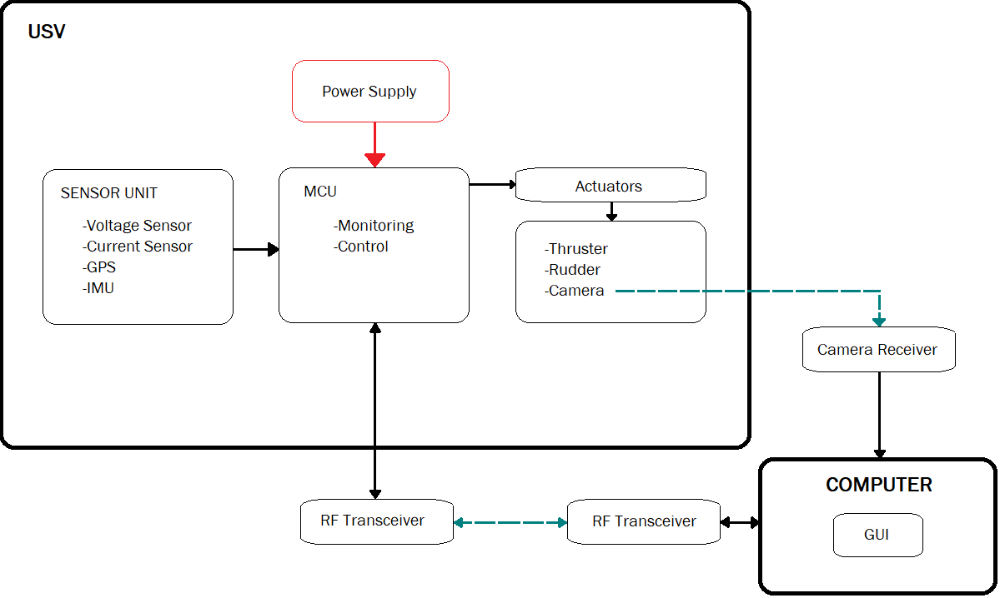

Figure 1.1 Conceptual Framework